

**Module Code & Module Title**

CS6PO5 Final Year Project

Digital ANFA

**Assessment Type**

**Year and Semester**

2019-20 Autumn

**Student Name:** Pranaya Pradhan **Internal Supervisor:** Rohit Pandey

**London Met ID:** 17030952 **External Supervisor:** Shekhar Timsina

**College ID:** np01cp4a170020

**Assignment Due Date:**

**Assignment Submission Date:**

**Word Count:**

*I confirm that I understand my coursework needs to be submitted online via Google Classroom under the relevant module page before the deadline for my assignment to be accepted and marked. I am fully aware that late submissions will be treated as non-submission and a mark of zero will be awarded.*

Table of Contents

1. Detailed Feature List 1

1.1. For Website (Admin/Editor) 1

1.2. For Mobile Application (User): 4

2. Wire Frame 6

2.1. Wire Frame of Website 6

2.1.1. Admin 7

2.1.2. Editor 13

2.2. Wire Frame of Mobile Application 19

3. Use Case of Each Feature 24

For Web(Admin/Editor) 25

3.2.1. Use Case of News Feed 25

3.2.2. Use Case of Fixtures 27

3.2.3. Use Case of Club Detail 29

3.2.4. Use Case of Player Detail 31

3.2.5. Use Case of Statistics 33

For Mobile (User) 35

3.2.6. Use Case of News Feed 35

3.2.7. Use Case of Fixtures 36

3.2.8. Use Case of Statistics 37

3.2.9. Use Case of Club Profile 38

4. System Architecture 39

5. Database Architecture – ERD 40

Table of Tables

Table 1 Keeps News in Feed 26

Table 2 Update the Fixtures 28

Table 3 Upload Club Detail 30

Table 4 Upload Player Detail 32

Table 5 Stores the Statistics 34

Table 6 Reads News in Feed 35

Table 7 Knows the Fixtures 36

Table 8 Use Case of Views Statistics 37

Table 9 Table of Views Stastistics 37

Table 10 Table of Gets Club and Player Detail 38

Table of Figure

Figure 1 Login 6

Figure 2 Register 6

Figure 3 Add Editor Dashboard 7

Figure 4 Admin News Section 7

Figure 5 Admin Club Detail Section 8

Figure 6 Admin Add Club Detail 8

Figure 7 Admin Player Section 9

Figure 8 Admin Add Player Section 9

Figure 9 Admin Fixture Section 10

Figure 10 Admin Add Fixture Section 10

Figure 11 Admin Statistics Highest Scorer Section 11

Figure 12 Admin Statistics Red Card Section 11

Figure 13 Admin Yellow Card Section 12

Figure 14 Editor News Feed Section 13

Figure 15 Editor Add News Feed Section 13

Figure 16 Editor Club Detail Section 14

Figure 17 Editor Club Detail Section 14

Figure 18 Editor Player Detail 15

Figure 19 Editor Add Player Detail 15

Figure 20 Editor Fixtures 16

Figure 21 Editor Add Fixtures 16

Figure 22 Editor Add Red Card 17

Figure 23 Editor Add Yellow Card 17

Figure 24 Editor Add Yellow Card 18

Figure 25 Splash Screen 19

Figure 26 News Feed Section 20

Figure 27 Fixture Section 21

Figure 28 Statistics Section 22

Figure 29 Profile Section 22

Figure 30 About Us Section 23

Figure 31 Overall Use Case 24

Figure 32 Adds News 25

Figure 33 Edit News 25

Figure 34 Delete the News 26

Figure 35 Add Fixtures 27

Figure 36 Edit the fixtures 27

Figure 37 Delete the Fixture 28

Figure 38 Add Club Detail 29

Figure 39 Edit Club Detail 29

Figure 40 Delete Club Detail 30

Figure 41 Use Case of Add Player Detail 31

Figure 42 Use Case of Delete Player Detail 32

Figure 43 Add Statistics 33

Figure 44 Edit Statistics 33

Figure 45 Delete Statistics 34

Figure 46 Use Case of News Feed 35

Figure 47 Use Case of Fixtures 36

Figure 48 Use Case of Club Profile 38

Figure 49 System Architecture of Digital ANFA 39

Figure 50 ERD Diagram 40

# Introduction

## Introduction to Topic

## Current Scenario

## Problem Domain

## Scope

## Aims and Objectives

# Background

## Project Elaboration

## Terms/Definition

## System Architecture

The following diagram represents the system architecture of the project:

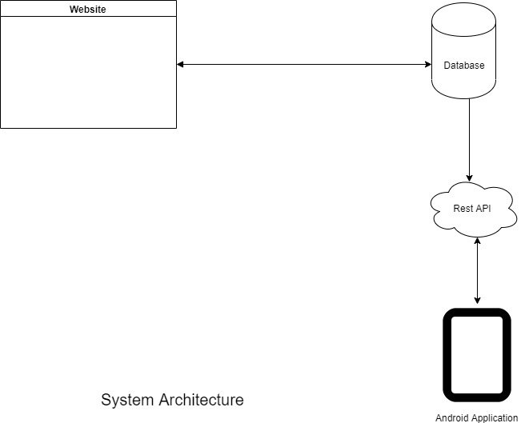

Figure 1 System Architecture of Digital ANFA

## Feature

### 2.4.1. For Web (Admin/Editor)

* Admin
* User
  + - Username
    - First Name
    - Last Name
    - Email
    - User Password
    - Actions:
      * Add the Editor
      * Update the Editor detail
      * Delete the Editor (if required)
* Admin and Editor
* News Feeds
* News Title
* News Type
* News Description
* News Image
* Date
* Actions:
  + Add the News
  + Update the News
  + Delete the News (if required)
* Club Detail
* Club Name
* Club Description
* Club Founded Date
* Club Address
* Club Email
* Club Division
* Club Affiliation
* Home Jersey Color
* Away Jersey Color
* Club Sponsor
* Kit Sponsor
* Club Logo
* Actions:

- Adds the Club details

- Update/Edit the Club details

- Delete the Club detail (if required)

* Player Detail
* First Name
* Last Name
* Date of Birth
* Place of Birth
* Gender
* Position
* Country
* Image
* Club Id
* Status (active/inactive)
* Actions:
  + Adds the Player details
  + Update/Edit the Players details
  + Delete the Player details (if required)
* Tournaments
  + - Tournament Id
    - Tournament Name
    - Tournament Type
    - Season
    - Title Sponsor
    - Organizers
    - Actions:
  + Adds the tournaments detail
  + Edit/Update the tournaments detail
  + Delete the tournaments detail
* Fixtures/Match
* Club 1
* Club 2
* Date
* Kick Off Time
* Venue
* Club 1 Score
* Club 2 Score
* Club 1 Result
* Club 2 Result
* Status (Played/Not Yet Played)
* Actions:
* Adds the match/fixtures detail
* Edit/Update the fixture detail
* Delete the fixture detail
* Statistics
* Highest Scorer
  + Player Id
  + Player First Name
  + Player Last Name
  + Club
  + Total Goals
* Red Card
  + Id
  + Player Name
  + Club
  + Total Cards
* Yellow Card
  + Id
  + Player Name
  + Club
  + Total Cards
* Clean Sheets
  + Id
  + Player Name
  + Club
  + Total Number of Clean Sheets
* Actions:
* Adds the Statistics detail
* Edit/Update the Statistics Detail
* Delete the Statistics Detail

### 2.4.2. For Mobile Application (User)

* News Feeds
* News Title
* News Description
* News Type
* News Image
* Date
* Actions:
  + Views the news feeds
* Club Detail
* Club Name
* Club Description
* Club Logo
* Club Address
* Club Email
* Club Telephone
* Club Affiliation
* Actions:

- Views the Club Detail

* Player Detail
* Player Name
* Date of Birth
* Place of Birth
* Position
* Jersey No
* Nationality
* Image
* Club Id
* Status (activate/deactivate)
* Actions:
  + Views the Player Detail

* Fixtures
* Club 1
* Club 2
* Date
* Time
* Venue
* Result
* Actions:
* Views the Fixtures
* Statistics
* Views Points Table
* Highest Scorer
  + Id
  + Player Name
  + Club
  + Total Goals
* Red Card
  + Id
  + Player Name
  + Club
  + Total Cards
* Yellow Card
  + Id
  + Player Name
  + Club
  + Total Cards
* Actions:
* Views the Statistics

## Wireframe

## Similar System

## Comparison

# Conclusion

# Wire Frame

## Wire Frame of Website

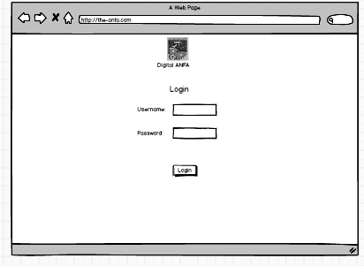

Figure 2 Login

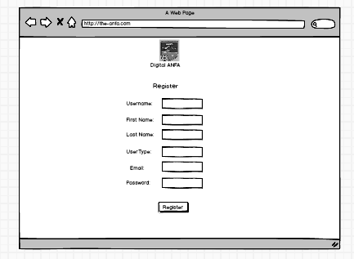

Figure 3 Register

## Admin

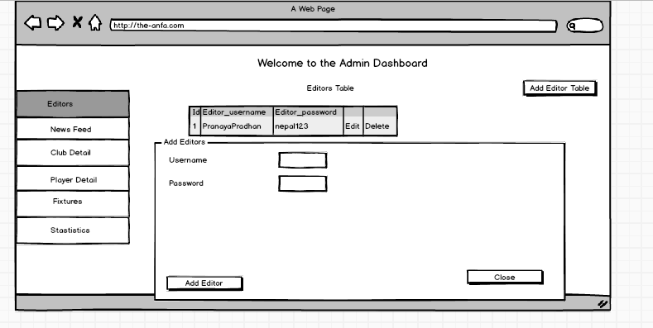

Figure 4 Add Editor Dashboard

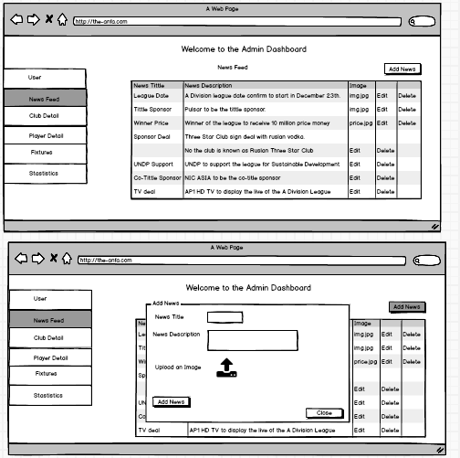

Figure 5 Admin News Section

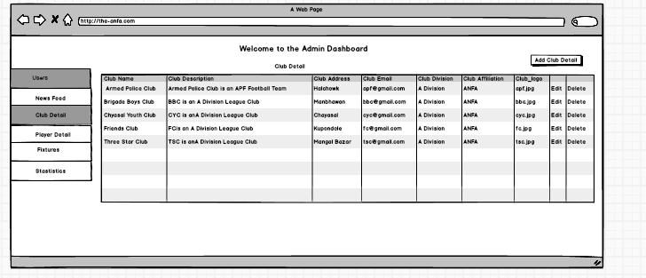

Figure 6 Admin Club Detail Section

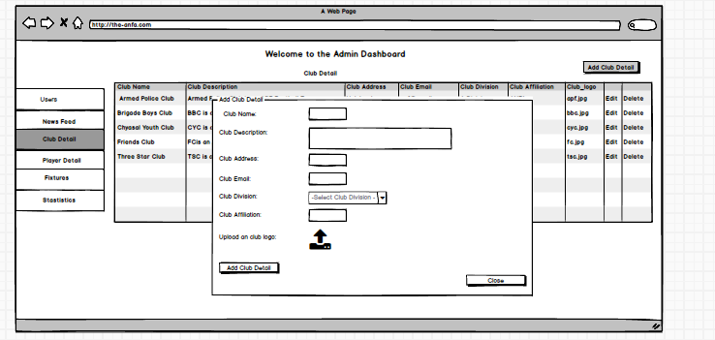

Figure 7 Admin Add Club Detail

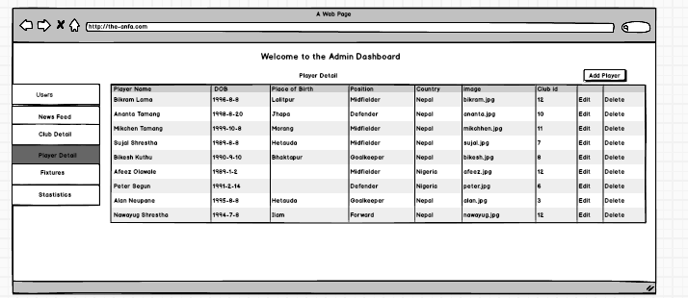

Figure 8 Admin Player Section

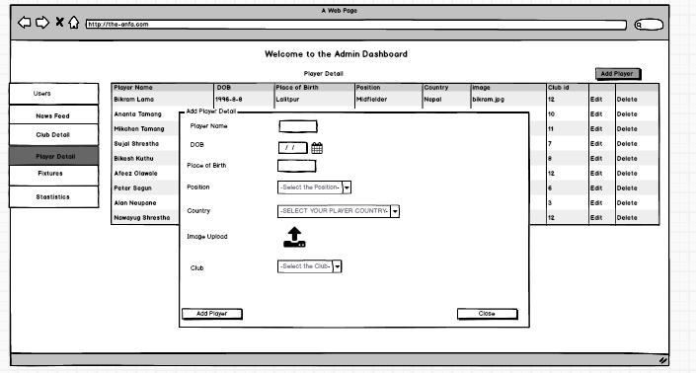

Figure 9 Admin Add Player Section

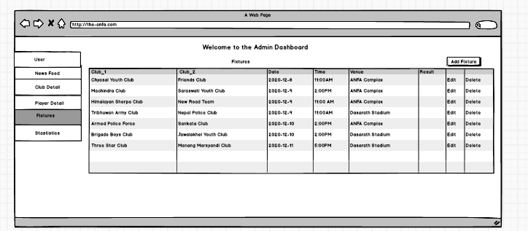

Figure 10 Admin Fixture Section

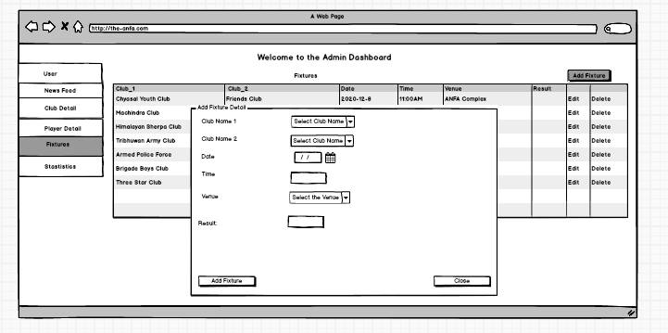

Figure 11 Admin Add Fixture Section

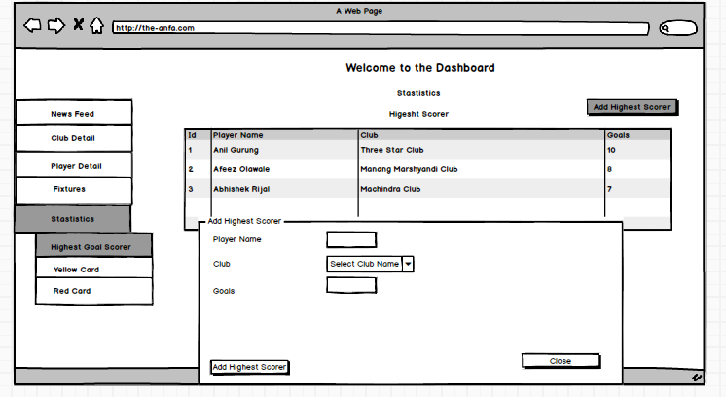

Figure 12 Admin Statistics Highest Scorer Section

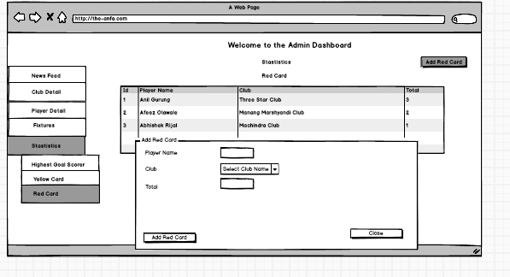

Figure 13 Admin Statistics Red Card Section

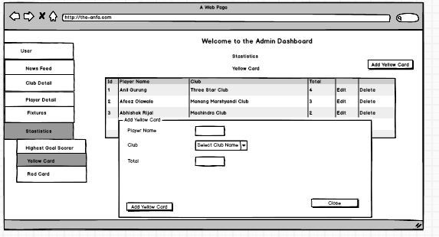

Figure 14 Admin Yellow Card Section

## Editor

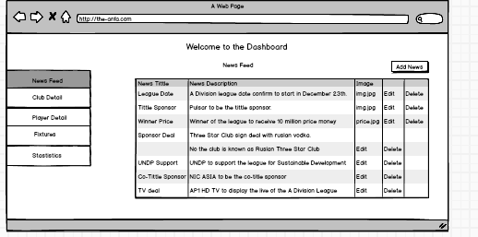

Figure 15 Editor News Feed Section

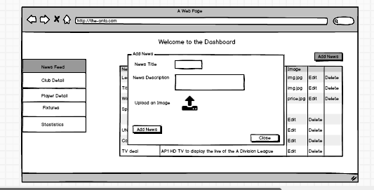

Figure 16 Editor Add News Feed Section

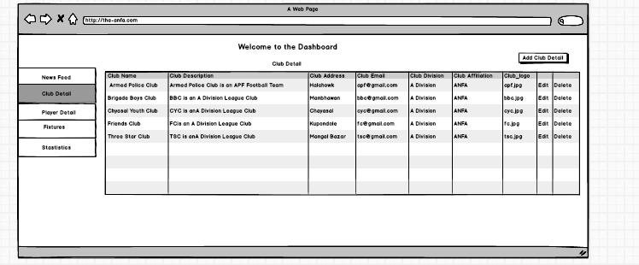

Figure 17 Editor Club Detail Section

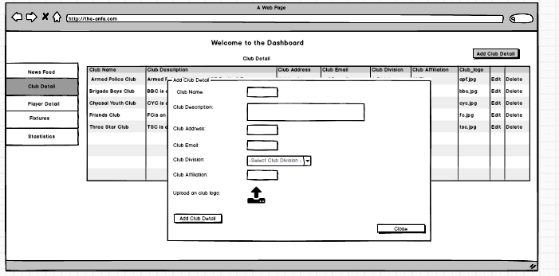

Figure 18 Editor Club Detail Section

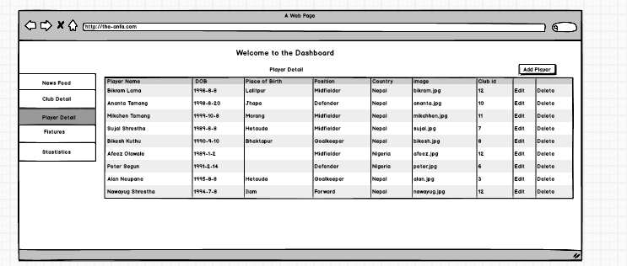

Figure 19 Editor Player Detail

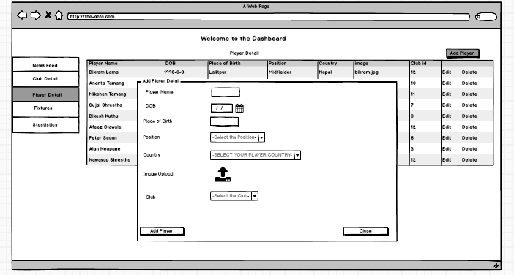

Figure 20 Editor Add Player Detail

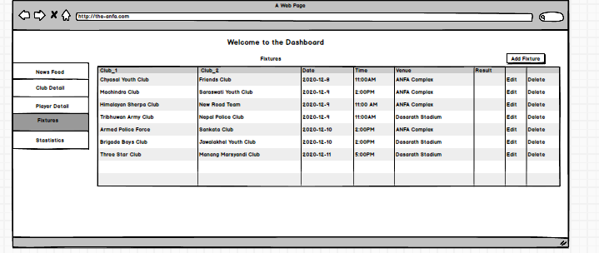

Figure 21 Editor Fixtures



Figure 22 Editor Add Fixtures

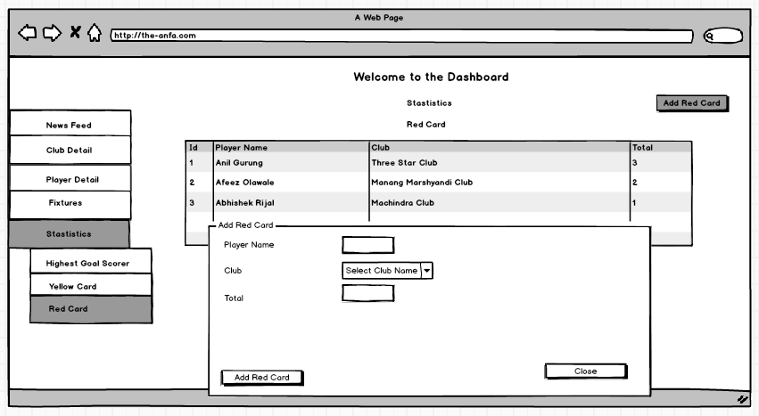

Figure 23 Editor Add Red Card

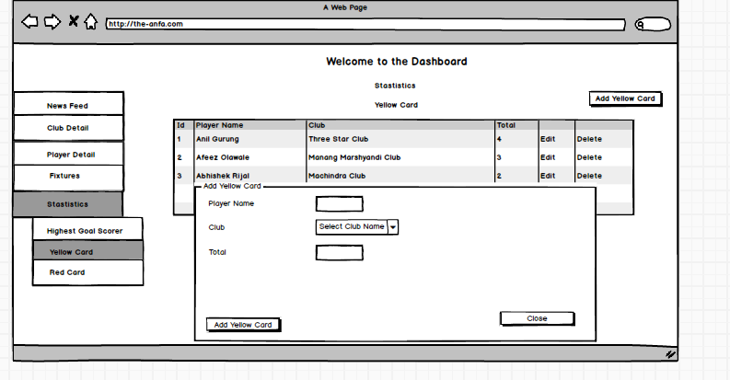

Figure 24 Editor Add Yellow Card



Figure 25 Editor Add Yellow Card

## Wire Frame of Mobile Application

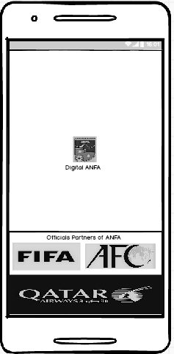

Figure 26 Splash Screen

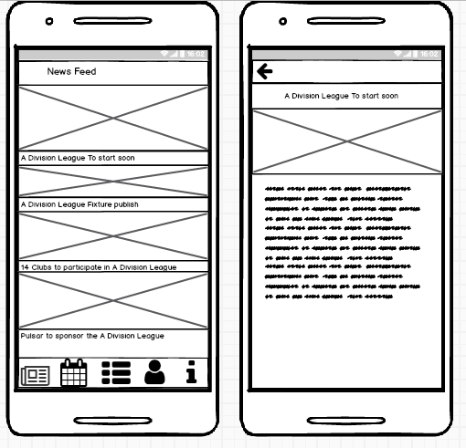

Figure 27 News Feed Section

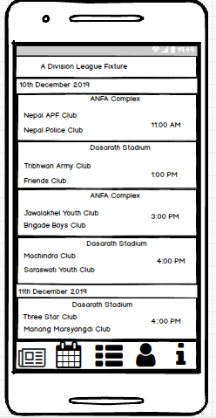

Figure 28 Fixture Section

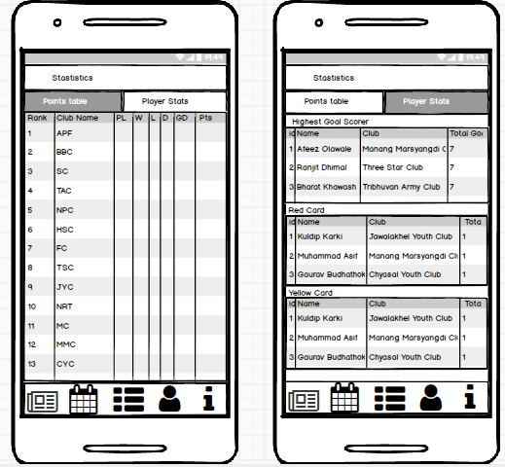

Figure 29 Statistics Section

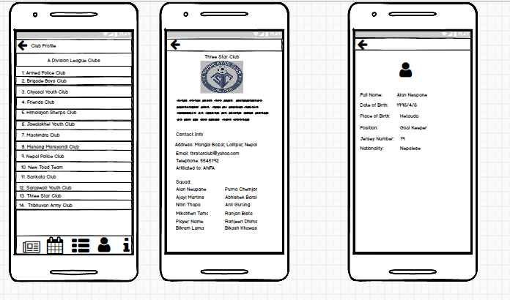

Figure 30 Profile Section

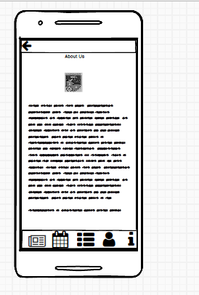

Figure 31 About Us Section

# Use Case of Each Feature



Figure 32 Overall Use Case

### For Web(Admin/Editor)

### Use Case of News Feed



Figure 33 Adds News



Figure 34 Edit News



Figure 35 Delete the News

|  |  |
| --- | --- |
| Name: | Keeps News in Feed |
| Actors: | Editor, Admin |
| Description: | The actors keep the news in the news feed section. He/she can add, edit and delete the news. |

Table 1 Keeps News in Feed

### Use Case of Fixtures



Figure 36 Add Fixtures



Figure 37 Edit the fixtures



Figure 38 Delete the Fixture

|  |  |
| --- | --- |
| Name: | Update the fixtures |
| Actors: | Editor, Admin |
| Description: | The actors have permission to update the fixture of the matches. |

Table 2 Update the Fixtures

### Use Case of Club Detail



Figure 39 Add Club Detail



Figure 40 Edit Club Detail



Figure 41 Delete Club Detail

|  |  |
| --- | --- |
| Name: | Upload Club Detail |
| Actors: | Editor, Admin |
| Description: | The actors have right to upload the club detail. Similarly, he/she can edit as well delete the detail if require. |

Table 3 Upload Club Detail

### Use Case of Player Detail



Figure 42 Use Case of Add Player Detail



Figure 42 Use Case of Edit Player Detail



Figure 43 Use Case of Delete Player Detail

|  |  |
| --- | --- |
| Name: | Upload Player Detail |
| Actors: | Editor, Admin |
| Description: | The actors have right to upload the player detail. Similarly, he/she can edit as well delete the detail if require. |

Table 4 Upload Player Detail

### Use Case of Statistics



Figure 44 Add Statistics



Figure 45 Edit Statistics



Figure 46 Delete Statistics

|  |  |
| --- | --- |
| Name: | Stores the Statistics |
| Actors: | Editor, Admin |
| Description: | The actors have an ability to record the statistics of the matches. |

Table 5 Stores the Statistics

### For Mobile (User)

### 3.2.6. Use Case of News Feed



Figure 47 Use Case of News Feed

|  |  |
| --- | --- |
| Name: | Reads the News in Feed |
| Actors: | User |
| Description: | The actors view the news tittle and images as well as can read the news. |

Table 6 Reads News in Feed

### 3.2.7. Use Case of Fixtures



Figure 48 Use Case of Fixtures

|  |  |
| --- | --- |
| Name: | Knows the Fixtures |
| Actors: | User |
| Description: | The actors can know the fixture of the match of tournament. |

Table 7 Knows the Fixtures

### 3.2.8. Use Case of Statistics



Table 8 Use Case of Views Statistics

|  |  |
| --- | --- |
| Name: | Views Statistics |
| Actors: | User |
| Description: | The actors have right to statistics of the match. |

Table 9 Table of Views Stastistics

### 3.2.9. Use Case of Club Profile



Figure 49 Use Case of Club Profile

|  |  |
| --- | --- |
| Name: | Gets Club and Player Detail |
| Actors: | User |
| Description: | The actors gets the detail of the clubs and players. |

Table 10 Table of Gets Club and Player Detail

# System Architecture

# Database Architecture – ERD

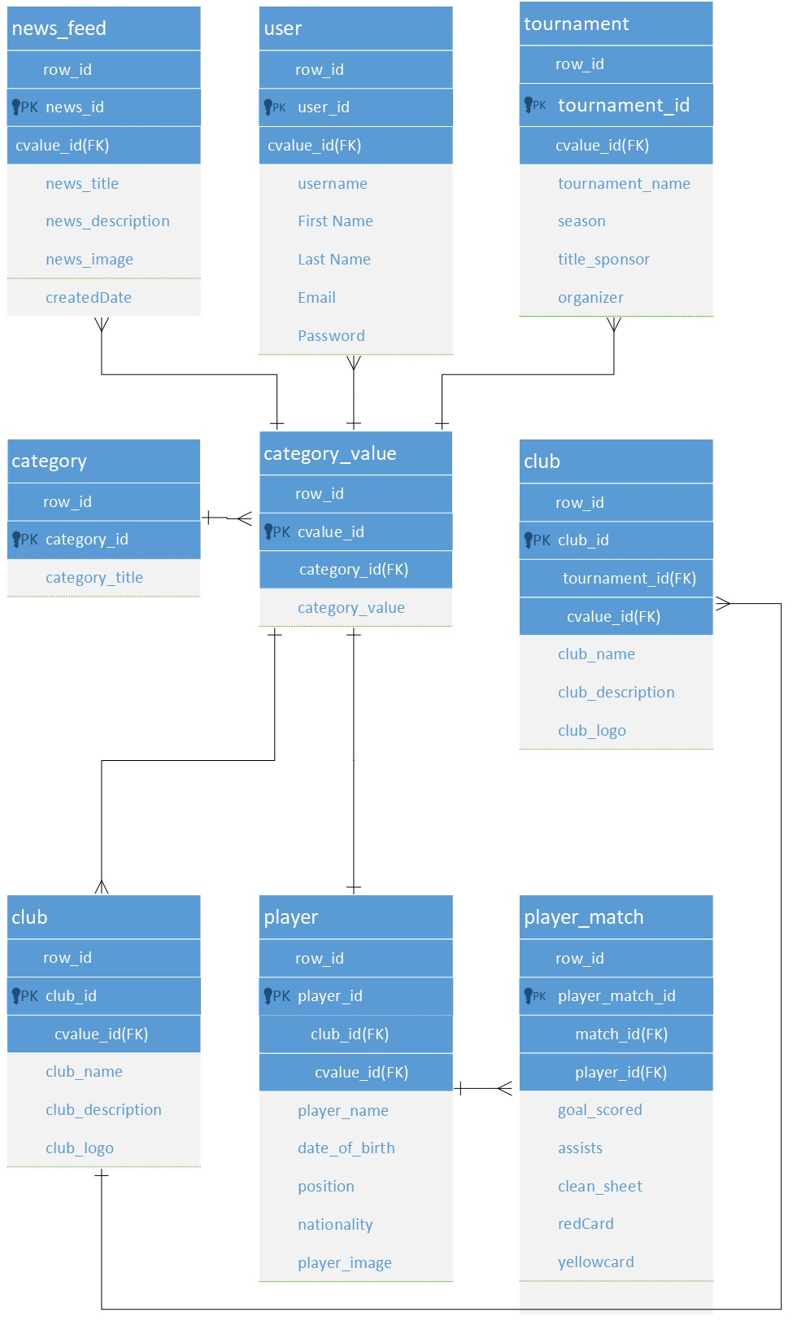

Figure 50 ERD Diagram